Topic 1: Measurements and Units
Objectives: At the end of this topic, students should be able to:
- Identify fundamental and derived units
- Understand how to use different measuring devices
- Relate the fundamental physical quantities to their units
- Deduce the units of derived quantities
- Determine the dimensions of physical quantities
- Use the dimensions to determine their units

Content:
- Physics is viewed as the study of matter in relation to its energy.
- It is primarily the study of nature; through the study of physics, we understand that
- The earth rotates about its central axis for 24 hours making a day
- The moon revolves about the earth for about 28days making a month
- The earth revolves about the sun for about 365days making a year
- A certain portion of the earth becomes dark regardless of the time when the sun cast the shadow of the moon at that portion, this is described as eclipse of the sun.
- Our primary activity in physics is to take measurements of physical quantities
- If there is no measurement, there is no physics
- Physical quantities are defined by their numeric values and units
- We take measurements by using the appropriate measuring device for the quantity
- In taking measurements;
- We will take note of the reading accuracy of the instruments used
- We will record our reading in the correct number of significant figures
- We will take the reading more than one time and record the average value, this is to ensure high level of accuracy
Notes:
- All measuring instrument are calibrated using small lines
- The distance between two successive lines is known as the reading accuracy of the instrument. The reading accuracy is the smallest possible accurate measurement we can take with the instrument.
- In recording the readings, we will state the estimated uncertainty also called the precision. The estimated uncertainty is the experimenter’s best estimate of how far the experimental quantity might be from the “true value”.

Measurement of Length
- Length is measured with different instrument depending on the size of the length
- The S.I. unit for length is meters(m). it can be expressed in smaller multiples such as cm, mm and in larger multiples such as km etc.
- The common instruments used are:
- Meter rule with reading accuracy 0.1cm
- Vernier calipers with reading accuracy 0.01cm
- Micro-meter screw gauge with reading accuracy 0.001cm
- One major error that must be avoided when taking reading on the instrument is “parallax error”. This is an error due to noting the reading from the side of the instrument. To avoid this error, reading should be taken by keeping your eye perpendicular and directly above the reading.
Illustrative Materials Needed
An image of the instruments are needed to explain how to read it.
Measurement Of Mass And Weight
- Mass is usually mistaken for weight but the two are different quantities
- Mass is the amount of matter in a body while weight is the measure of gravitational pull on the body
- The S.I. unit for mass is kilogram. Though, it can be measured in grams, milligrams, tonnes etc.
- Mass is measured with the use of beam balance.
- Beam balance has reading accuracy of 0.001g
- Beam balance operates with the principle of moment.
- Weight is measured with the use of spring balance having reading accuracy of
- Spring balance operates according to Hooke’s law
Measurement of Time
- Time is a dimension in which events can be ordered from the past through the present to the future.
- Its S.I. units is seconds. Though, it can be measured in other units such as minutes, hours etc.
- Time is measured with stop watch or stop clock with reading accuracy of 0.1secs
PHYSICAL QUANTITY
- Physical quantity are broadly classify into two: Fundamental and derived quantities
- Fundamental Quantities are basic quantity i.e. they form the building block for other quantities.
- There are seven fundamental quantities. The table below shows the fundamental quantities with their S.I. units.

Fundamental Quantity | S.I. Units | Dimensions
Mass | Kilogram(kg) | M
Length | Meter(m) | L
Time | Seconds(s) | T
Temperature | Kelvin(k)
Light Intensity | Candela(cd)
Electric Current | Ampere(A) | I
Amount of Substance | Mole(Mol)

- Derived Quantities are quantities obtained from the product or quotient of fundamental quantities. Examples include;
Area= length X length
Volume= length X length X length
Speed= $\frac{Lenght}{Time}$
- The relationship between a physical quantity and its basic unit is called “Dimension”
Examples on Dimension;
Quantity | Unit | Dimension
Area | $$m^{2}$$ | $$L^{2}$$
Density | $$\frac{mass}{volume} {kgm}^{-3}$$ | $${ML}^{-3}$$
Speed | $$\frac{distance}{time} {ms}^{-1}$$ | $${LT}^{-1}$$
Force | $$\frac{mass}{acceleration} {kgms}^{-2}$$ | $${MLT}^{-2}$$

Some quantities are neither fundamental nor derived. These are supplementary quantities and they are plane angle and solid angles.
Plane angle: is measured in radians.
Solid angle: is measured in steradians.
Importance of Dimensional Analysis
- It is used to check the correctness of an equation. An equation is correct if it is dimensionally consistent i.e. the dimension of each term must be the same.
e.g.
S= ut + $\frac{1}{2}{at}^{2}$
where s,u,a and t represent distance, speed, acceleration and time respectively. Show that the equation is dimensionally correct.
1st term: S→ L
2nd term: ut → L$T^{-1}$ . T → L
3rd term: $\frac{1}{2}{at}^{2}$ → L$T^{-2}$ . $T^{2}$ → L
The dimension of each term is L
Thus, the equation is dimensionally correct.
- It is also used to suggest the relationship between physical quantities.
Example: The period of oscillation, T, of a simple pendulum and acceleration of free fall due to gravity(g). Using dimensional analysis, express T in terms of l and g.
Solution:
T $∝$ $L^{x}$ $g^{y}$
T= k $L^{x}$ $g^{y}$
Where k is a dimensionless constant, x and y are constants to be determined.
Using Dimensional Analysis
1st term: T → T
2nd term: k $L^{x}$ $g^{y}$ → $L^{x}$ ${(Lr^{-2})}^{y}$ $→ L^{x+y}$ $T^{-2y}$
i.e.
T= $L^{x+y}$ $T^{-2y}$
$L^{°}T$ = $L^{x+y}$ $T^{-2y}$
Comparing powers(indices)
L: x+ y= 0 $→$x= -y
T: -2y = 1 $→$ y= -$\frac{1}{2}$
x = - (-$\frac{1}{2}$ )
x = $\frac{1}{2}$
Thus: T= k $L^{1/2}$ $g^{1/2}$
T = ${K√}^{\frac{l}{g}}$

DRILL
- Which of the following is a derived unit?
- Kilogram (b) Meter (c) Kelvin (d) Newton
- When a brick is taken from the earth’s surface to the moon, its mass
- Remains constant
- Reduces
- Increases
- Becomes zero
- What is the least possible error encountered when taking measurement with the meter rule?
- 0.1cm
- 1.0cm
- 0.5cm
- 0.2cm
- In order to remove the error of parallax when taking measurements with a meter rule , the eye should be focused
- Slantingly towards the left on the markings
- Slantingly towards the right on the markings
- Vertically downwards on the markings
- Vertically upwards on the markings
- The value of x,y and z respectively in the expression $M^{x}L^{y}T^{z}$ for the universal gravitational constant G are
- 2, -3, -2
- -1, 3, -2
- -1, 2, 3
- -2, -1, 3
- (I) Diameter of a small ball bearing
(II) Thickness of a piece of paper
(III) Diameter of a measuring cylinder
(IV) Length of a piece of wire
Which of the above can be measured using a micrometer screw guage?
- I, II and IV only
- I and II only
- II and III only
- III and IV only
- The dimensions of electromotive force are
- $ML^{2}T^{-3}I^{-1}$
- $ML^{2}T^{-3}I^{-2}$
- $M^{2}LT^{2}I^{-1}$
- $M^{2}L^{2}T^{2}I^{-1}$

- (I) Force(N)
(II) Torque (${NM}^{-1}$)
(III) Current (A)
(IV) Power(W)
Which of the above are the correct S.I. units of the quantities indicated
- I and II only
- I and III only
- I, II and III only
- I, III and IV only
- The moment of a couple can be expressed in
- ${Nm}^{-1}$
- ${Nm}^{-2}$
- Nm
- ${Nm}^{2}$
- Which of the following instruments is the best for measuring the diameter of a thin constantan wire?
- Calipers
- Micrometer screw gauge
- Meter rule
- Vernier caliper
- The unit of pressure can be expressed as
- kgm$s^{-2}$
- kg$m^{-1}s^{-2}$
- kg$m^{-2}s^{-2}$
- kg$m^{-1}s^{2}$
- Which of the following units is equivalent to the watt?
- kg$m^{2}$
- kg$m^{2}s^{-3}$
- kg$m^{2}s^{2}$
- kg$m^{2}s^{-1}$
- The S.I. unit of power is
- N
- Pa
- W
- I

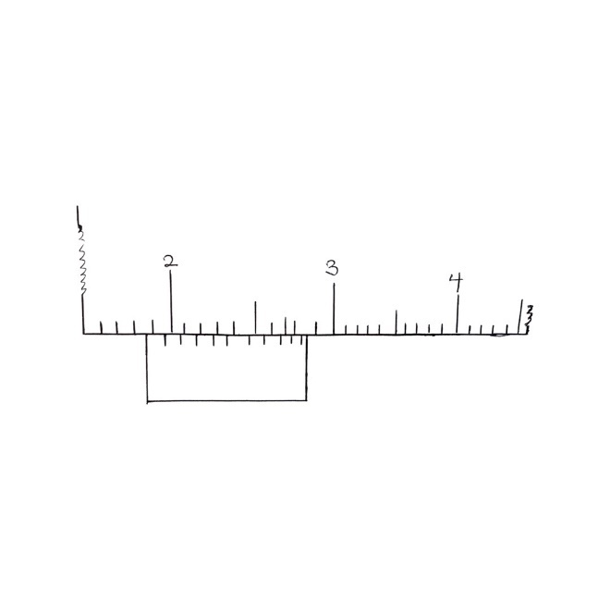

What is the reading of the Vernier caliper above?
- 1.88cm
- 1.80cm
- 1.28cm
- 1.97cm
- Which of the following has the same unit as watt?
- Force x Time
- Force x distance
- Force x acceleration
- Force x velocity
SOLUTION TO DRILLS
- Kilogram is the unit of mass which is fundamental
- Meter is the unit of length which is fundamental
- Kelvin is the unit of temperature which is fundamental
- Newton is the unit of force which is not fundamental
Hence, the derived unit is Newton (D)
- (A) : Mass is the same everywhere and at any time
- The least possible error encountered in a measuring instrument is the distance between the successive small lines.
- For meter rule: least possible error=1mm = 0.1cm (A)
- (C) The parallax error is avoided by positioning your eye above the markings and perpendicularly to the rule.
- Gravitational constant: G= $\frac{Fr^{2}}{m_{1 m_{2}}}$ = $\frac{{Nm}^{2}}{{kg}^{2}}$
=$\frac{{kgms}^{-2 }. m^{2}}{{kg}^{2}}$
= ${kg}^{-1}m^{3}s^{-2}$
= $M^{-1}L^{3}T^{-2}$
By comparison:
M: x= -1
L: y=3
T: z= -2
i.e (-1, 3, -2) ------------------(B)
- B
- EMF= $\frac{Workdone}{Charge}$
= $\frac{Force X Distance}{electric current X time}$
= $\frac{{kgms}^{-2 } X m}{A X S}$
= ${kgm^{2}s}^{-3 } A^{-1}$
= $ML^{2}T^{3} I^{-1}$ -----------(A)
- D
- Moment of a couple = Force X Arm of the Couple
= N X M
= Nm
- B
- Pressure = $\frac{Force}{Area }$
= $\frac{{kgms}^{-2 } }{m^{2}}$
= ${kgm^{-1}s}^{-2}$---------- (B)
- Watt $→$ unit power = $\frac{Workdone}{ time}$
= $\frac{Force X Distance}{time}$
= $\frac{{kgms}^{-2 } X m}{s}$
= ${kgm^{2}s}^{-3 }$---------B
- (C)
- Main Scale reading= 1.8
Vernier scale reading= 0.08
Total reading =1.88cm ------------(A)
- Watt= power
=$\frac{Force X Distance}{time}$
=$\frac{force}{1 } × \frac{distance}{time}$
= force $×$ speed
=force $×$ velocity-----------(D)

